State Diagram

“A state diagram consists of states, drawn as rounded rectangles, and transitions, drawn as arrows connecting the states. A transition represents a change of state, or how to get from one state to the next. A state is active when entered through a transition, and it becomes inactive when exited through a transition.” Miles, Russ; Hamilton, Kim (2008-12-17). Learning UML 2.0 (Kindle Locations 5544-5547). OReilly Media - A. Kindle Edition.

“A state is a condition of being at a certain time. A state can be a passive quality, such as On and Off for the light object. A state can also be an active quality, or something that an object is doing. For example, a coffeemaker has the state Brewing during which it is brewing coffee. A state is drawn as a rounded rectangle with the name of the state in the center” Miles, Russ; Hamilton, Kim (2008-12-17). Learning UML 2.0 (Kindle Locations 5586-5589). OReilly Media - A. Kindle Edition.

A state diagram basically is a way to track and display the different conditions, or states that a system goes through

A Transition in a State Diagram represents a change from one state to another state. These are typically represented as arrows in a diagram

Example of State Diagram with transitions:

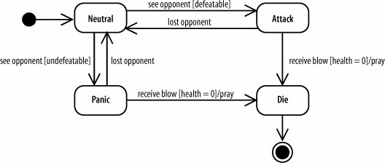

This example shows a simple state diagram from a software game. In this game the enemy has 4 different “modes” or “States.” Depending on the state, the enemy exhibits different behaviors. There is a transition between behaviors that controls when certain states are moved into. From the diagram, you see it begins in the “neutral” state. We can assume that in this case, the enemy performs its default behaviors, such as wandering, or patrolling, or guarding or whatever it normally does. When approached, the enemy has different options, based upon the power level of the opponent, causing it to either attack or to panic. When in either of those states, it can either transition to the final state, death and end or transition back to neutral state and repeat the process over after losing the opponent.